**Nitte Meenakshi Institute of Technology**

(AN AUTONOMOUS INSTITUTION AFFILIATED TO VISVESVARAYA TECHNOLOGICAL UNIVERSITY, BELGAUM

Department of Information Science & Engineering

**Web Lab LA2 PROJECT REPORT**

**TODOLIST NODEJS APP USING MONGODB, EXPRESS , MONGOOSE.**

**Submitted By:**

**Akshata B A 1nt19is401**

**Lavanya K 1nt19is407**

**Renuka Karadagi 1nt19is412**

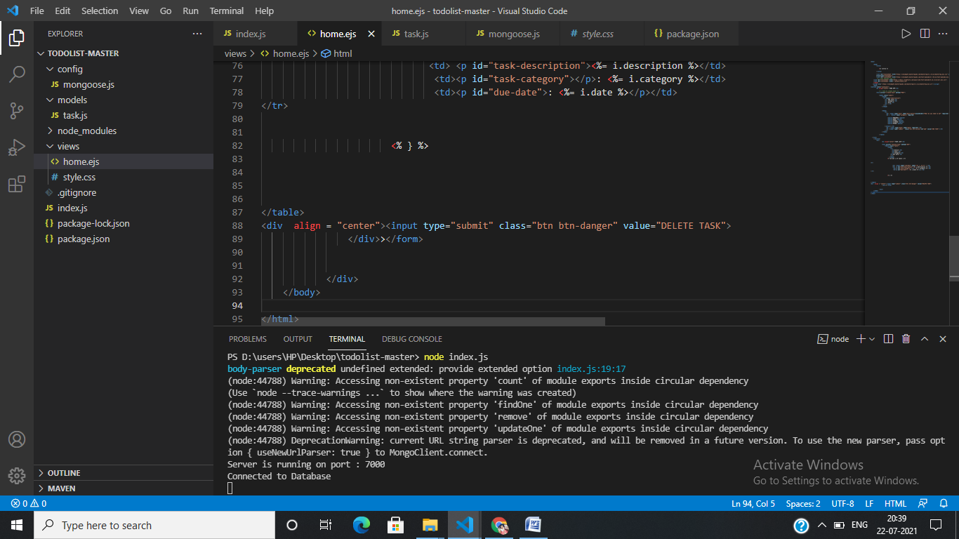

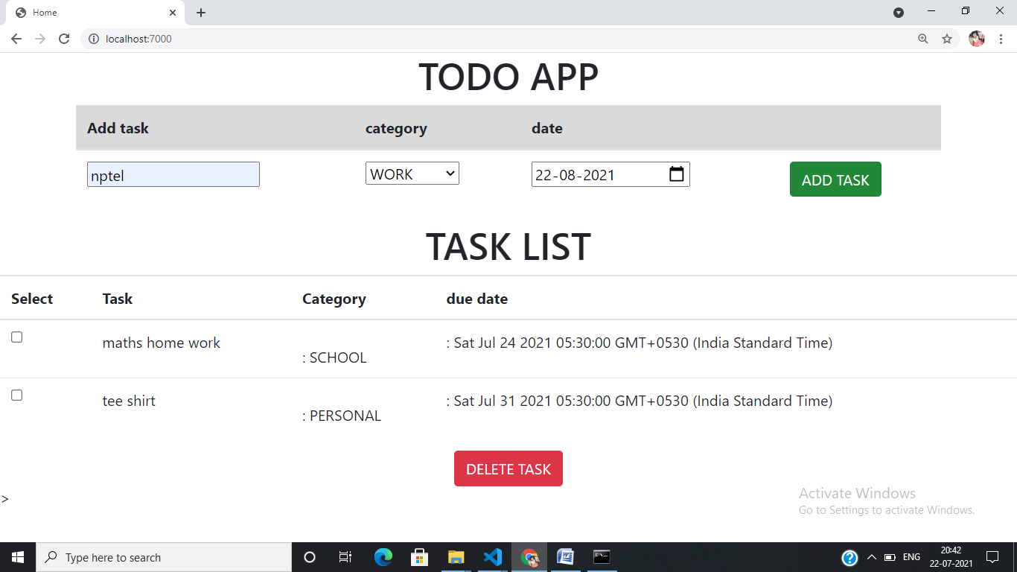

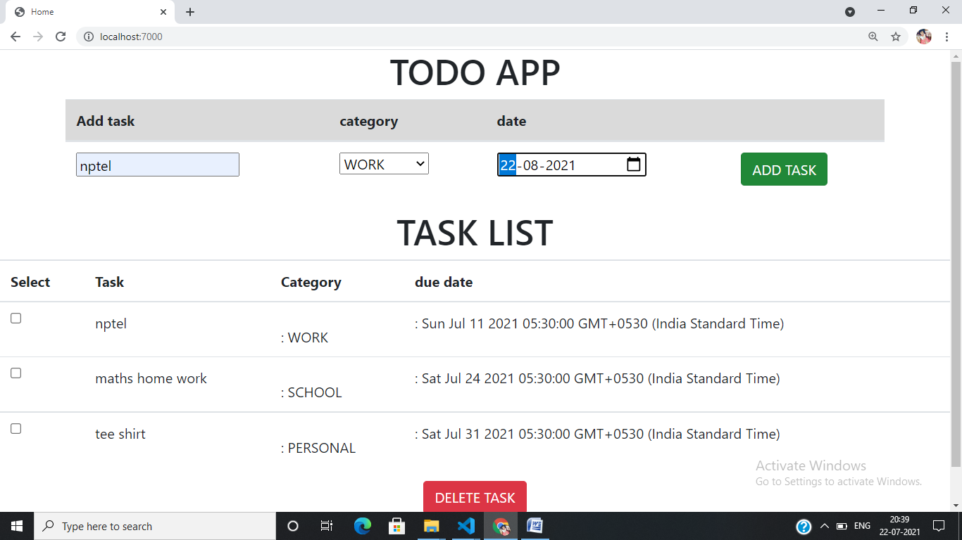

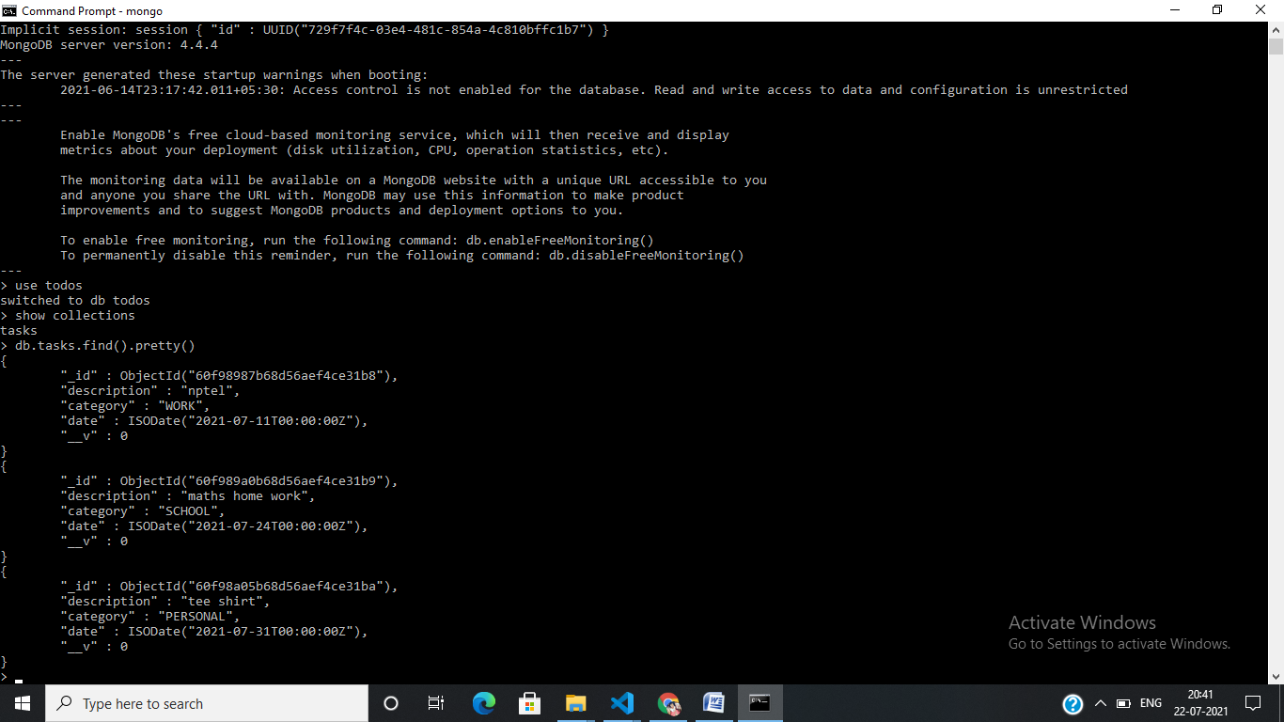

**DELETE**

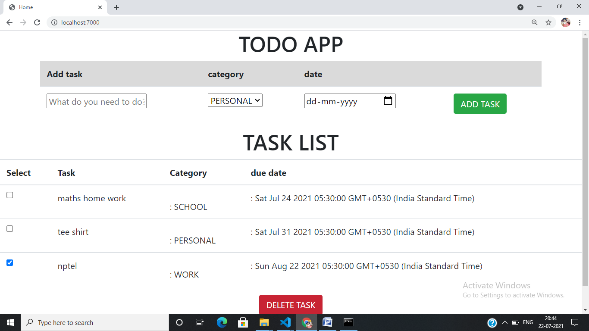

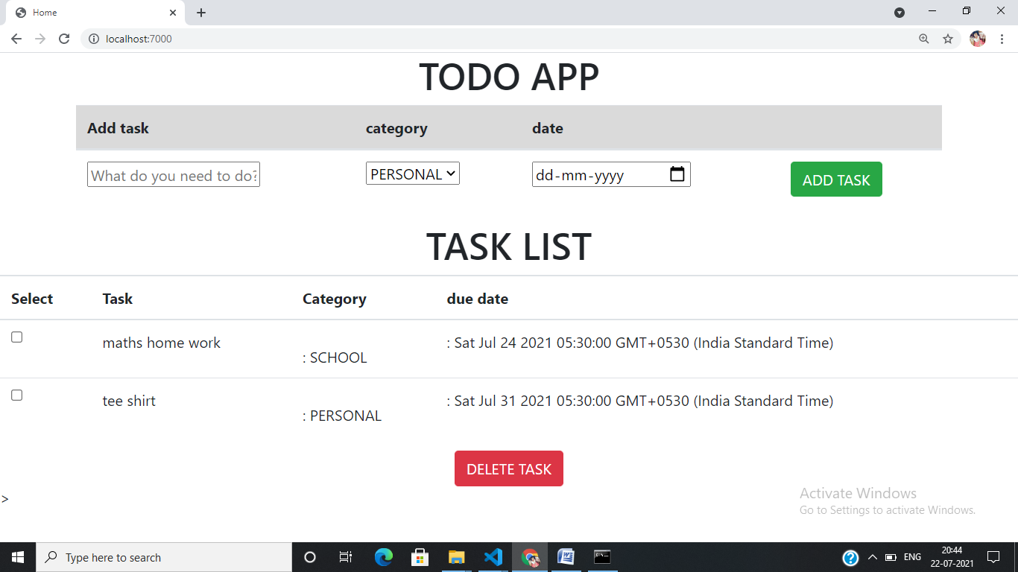

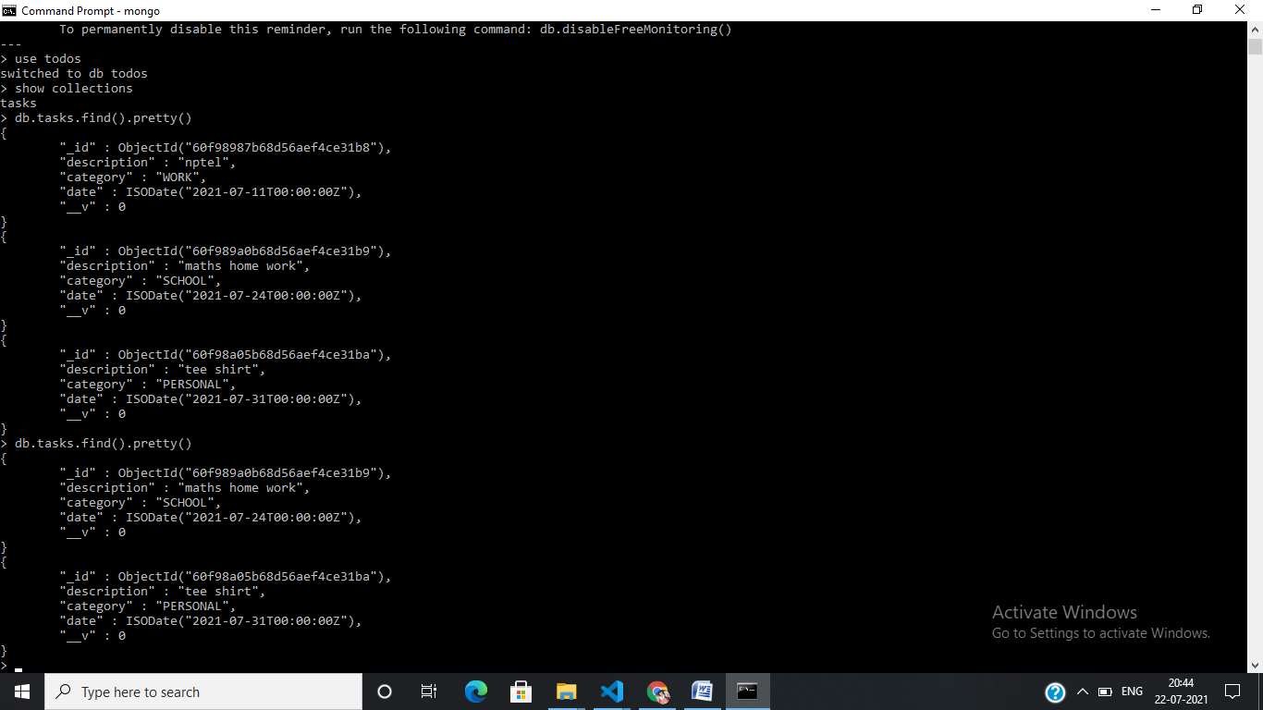

**Initially have to install npm**

**To run my app- nodemon index.js**

**On localhost 7000**

**Later , in that we can add the task.**

**It is simple app to understand how the node architecture works.**

**In that mongo file ,creates the connection to database**

**After importing the schema , it contains the description which all given in the app content .**

**If we want to delete task , have to select the specific ID of the task. The controller depend on the on the js only .**

**Index.js**

**// require express for setting up the express server**

**const express = require('express');**

**// set up the port number**

**const port = 7000;**

**// importing the DataBase**

**const db = require('./config/mongoose');**

**// importng the Schema For tasks**

**const Task = require('./models/task');**

**// using express**

**const app = express();**

**// using static files**

**app.use(express.static("./views"));**

**// to use encrypted data**

**app.use(express.urlencoded());**

**// set up the view engine**

**app.set('view engine', 'ejs');**

**app.set('views', './views');**

**// rendering the App Page**

**app.get('/', function(req, res){**

**Task.find({}, function(err, task){**

**if(err){**

**console.log('Error in fetching tasks from db');**

**return;**

**}**

**return res.render('home', {**

**tittle: "Home",**

**task: task**

**});**

**}**

**)});**

**// creating Tasks**

**app.post('/create-task', function(req, res){**

**// console.log("Creating Task");**

**Task.create({**

**description: req.body.description,**

**category: req.body.category,**

**date: req.body.date**

**}, function(err, newtask){**

**if(err){console.log('error in creating task', err); return;}**

**//console.log(newtask);**

**return res.redirect('back');**

**});**

**});**

**// deleting Tasks**

**app.get('/delete-task', function(req, res){**

**// get the id from query**

**var id = req.query;**

**// checking the number of tasks selected to delete**

**var count = Object.keys(id).length;**

**for(let i=0; i < count ; i++){**

**// finding and deleting tasks from the DB one by one using id**

**Task.findByIdAndDelete(Object.keys(id)[i], function(err){**

**if(err){**

**console.log('error in deleting task');**

**}**

**})**

**}**

**return res.redirect('back');**

**});**

**// make the app to listen on asigned port number**

**app.listen(port, function(err){**

**if(err){**

**console.log(`Error in running the server : ${err}`);**

**}**

**console.log(`Server is running on port : ${port}`);**

**});**

**Package.json**

**{**

**"name": "todo_app",**

**"version": "1.0.0",**

**"description": "first project of node",**

**"main": "index.js",**

**"scripts": {**

**"start": "nodemon index.js",**

**"test": "echo \"Error: no test specified\" && exit 1"**

**},**

**"keywords": [**

**"todo",**

**"app"**

**],**

**"author": "anurag",**

**"license": "",**

**"dependencies": {**

**"body-parser": "^1.19.0",**

**"ejs": "^2.7.1",**

**"express": "^4.17.1",**

**"mongoose": "^5.6.12"**

**}**

**}**